

Practices for Secure Software Report

Table of Contents
Document Revision History 3
Client 3
Instructions 3
Developer 4
1. Algorithm Cipher 4
2. Certificate Generation 4
3. Deploy Cipher 5
4. Secure Communications 5
5. Secondary Testing 6
6. Functional Testing 6
7. Summary 7
8. Industry Standard Best Practices 7

Document Revision History

Version | Date | Author | Comments
1.0 | [Date] | [Your Name]

Client



Instructions

Submit this completed practices for secure software report. Replace the bracketed text with the relevant information. You must document your process for writing secure communications and refactoring code that complies with software security testing protocols.

- Respond to the steps outlined below and include your findings.
- Respond using your own words. You may also choose to include images or supporting materials. If you include them, make certain to insert them in all the relevant locations in the document.
- Refer to the Project Two Guidelines and Rubric for more detailed instructions about each section of the template.

Developer
Mason Butler

Algorithm Cipher

The encryption algorithm selected for this project was SHA-256, which is part of the Secure Hash Algorithm (SHA-2) family developed by the National Security Agency (NSA). SHA-256 is a cryptographic hash function that converts input data into a fixed-length 256-bit hash value. This algorithm is widely used for data integrity verification because even a small change in the input data produces a completely different hash value.
SHA-256 uses a 256-bit output and is considered secure against known collision and preimage attacks. Unlike encryption algorithms, hash functions are one-way functions that cannot be reversed to reveal the original data. In this project, SHA-256 was implemented to generate a checksum that allows users to verify that transmitted data has not been altered during communication.
Modern secure communication systems often combine hash functions with symmetric and asymmetric encryption algorithms. Symmetric encryption uses a shared secret key for encryption and decryption, while asymmetric encryption uses a public and private key pair. Random numbers are used extensively in cryptographic systems to generate secure keys, certificates, and session tokens. In this project, RSA public-key cryptography was used during certificate generation while SHA-256 was used to verify data integrity.
Encryption algorithms have evolved significantly over time. Earlier algorithms such as DES are now considered insecure due to their shorter key lengths. Modern algorithms such as AES and RSA remain industry standards for protecting sensitive information. SHA-256 continues to be one of the most trusted hash algorithms and is widely used in financial systems, digital certificates, and secure communications.

Certificate Generation
Insert a screenshot below of the CER file.
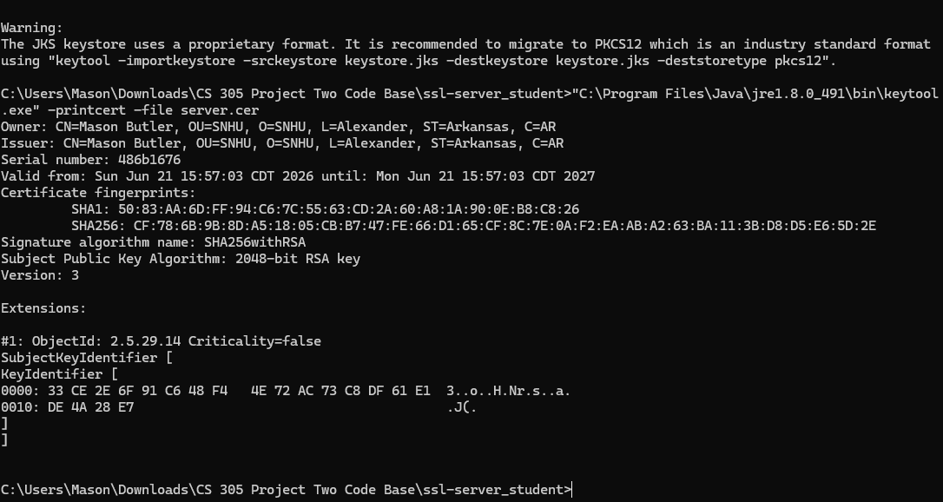

Deploy Cipher
Insert a screenshot below of the checksum verification.
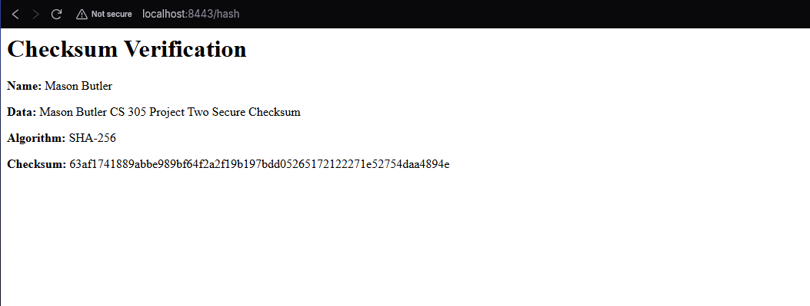

Secure Communications
Insert a screenshot below of the web browser that shows a secure webpage.

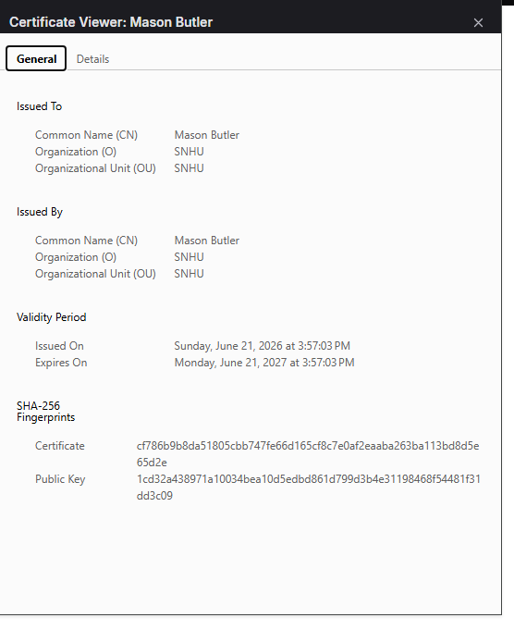

Secondary Testing
Insert screenshots below of the refactored code executed without errors and the dependency-check report.
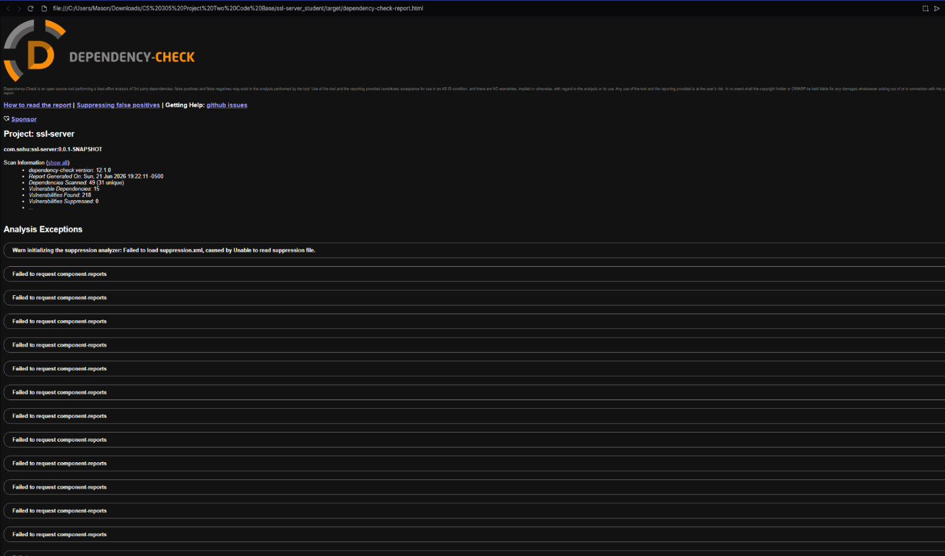

Functional Testing
Insert a screenshot below of the refactored code executed without errors.
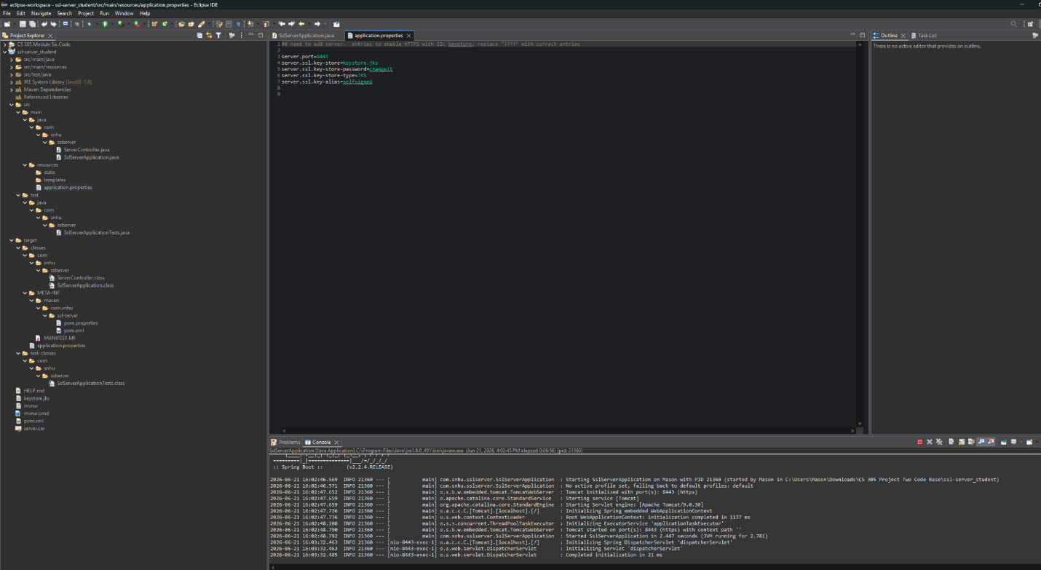

Summary
The Artemis Financial application was refactored to improve secure communications and data integrity. A SHA-256 checksum verification feature was added to validate transmitted data. A self-signed certificate was generated and configured to enable HTTPS communication through Spring Boot. The application was successfully tested to confirm secure communication and proper checksum generation.

The vulnerability assessment process included reviewing the application for weaknesses, implementing secure communication controls, performing checksum verification, generating certificates, and conducting dependency analysis through OWASP Dependency-Check. These improvements have added multiple layers of security that help protect sensitive financial information from tampering and unauthorized access. The completed solution demonstrates the use of encryption, secure communications, certificate management, and security testing techniques commonly used in modern software development.

Industry Standard Best Practices
Industry standard secure coding practices were applied throughout this project. SHA-256 was selected because it is a widely accepted cryptographic hashing algorithm that provides strong protection against collisions and data tampering. HTTPS was implemented using SSL/TLS certificates to encrypt communication between clients and the server. Secure certificate management practices were followed using Java Keytool and a dedicated keystore.

OWASP Dependency-Check was used to identify known vulnerabilities in project dependencies and support secure software development practices. Maintaining secure coding standards helps protect customer information, reduce security risks, and improve software reliability. For Artemis Financial, these best practices help safeguard sensitive financial data, maintain customer trust, and support regulatory compliance requirements associated with secure financial systems.

